SOFTWARE TESTING REPORT

Agrigene-AI-Based Crop Recommendation System

1. Introduction
The Agrigene AI-Based Crop Recommendation System is a machine-learning-based application developed to assist farmers and agricultural users in selecting suitable crops based on soil and environmental conditions. The system accepts parameters such as nitrogen, phosphorus, potassium, temperature, humidity, soil pH, and rainfall and uses trained machine-learning models to recommend an appropriate crop.
In addition to crop recommendation, the application provides:
- Soil health diagnosis
- Soil pH classification
- Nutrient deficiency warnings
- Fertilizer recommendations
- Weather information
- Prediction confidence
- Prediction history
- SQLite-based storage of saved records
- Dashboard and advisory functionality
The application is implemented as a Streamlit web application and is accessed locally through:
http://localhost:8501
Software testing was performed to verify the correctness, reliability, integration, and end-to-end behaviour of the system.
The following testing techniques were considered:
- Unit Testing
- White-Box Testing
- Black-Box Testing
- Integration Testing
- System Testing

2. Objectives of Testing
The major objectives of testing the AI-Based Crop Recommendation System were:
- To verify that individual functions perform their intended operations correctly.
- To verify the different decision branches present in the soil diagnosis logic.
- To verify that invalid and boundary inputs are handled appropriately.
- To verify communication between different components of the application.
- To verify that crop prediction, soil diagnosis, fertilizer recommendation, weather information, and database storage work together correctly.
- To verify the complete application workflow from user input to final output.
- To identify errors and inconsistencies before deployment.
- To ensure that the application produces meaningful results for valid agricultural inputs.

3. Testing Environment
Parameter | Configuration
Application | AI-Based Crop Recommendation System
Interface | Streamlit Web Application
Operating System | Windows
Python Version | Python 3.14.3
Python Executable | C:\Python314\python.exe
Testing Framework | pytest
pytest Version | 9.1.1
Database | SQLite
Application URL | http://localhost:8501
Main Application | app.py
Dataset | Crop_recommendation.csv
Machine Learning | Random Forest, Decision Tree, KNN, SVM, Gaussian Naive Bayes

4. Testing Methodology
Testing was performed at different levels so that both individual functions and the complete application could be evaluated.
The testing hierarchy used was:

SOFTWARE TESTING
│
┌────────────────┼────────────────┐
│ │ │
Unit Testing White-Box Testing Black-Box Testing
│ │ │
└────────────────┼────────────────┘
│
Integration Testing
│
System Testing
Each level focuses on a different aspect of the software.

5. Unit Testing

5.1 Definition
Unit testing is the process of testing individual functions or modules independently to determine whether each component behaves according to its specification.
For this project, the diagnose_soil() function was selected for unit testing because it contains several decision conditions related to:
- Soil pH
- Nitrogen
- Phosphorus
- Potassium
- Soil warnings
- Soil score
- Soil rating
The unit tests were implemented using pytest.

5.2 Function Tested
The main function tested was:
diagnose_soil()
The function analyses soil parameters and returns information including:
- ph_class
- ph_desc
- ph_action
- ph_color
- warnings
- score
- rating
- rating_color
The nutrient conditions are represented through the generated warning information rather than separate n_status, p_status, and k_status return fields.

6. Unit Test Cases

6.1 pH Classification Testing
The soil diagnosis function contains five major pH classifications.
Test ID | Condition | Input pH | Expected Result
UT01 | Strongly acidic | < 5.5 | Strongly Acidic
UT02 | Moderately acidic | 5.5 ≤ pH < 6.0 | Moderately Acidic
UT03 | Optimal | 6.0 ≤ pH ≤ 7.5 | Optimal / Neutral
UT04 | Moderately alkaline | 7.5 < pH ≤ 8.5 | Moderately Alkaline
UT05 | Strongly alkaline | > 8.5 | Strongly Alkaline
These tests verify that the function correctly identifies the major pH categories.

6.2 pH Boundary Testing
Boundary values are particularly important because classification errors commonly occur at the limits of conditional statements.
The following boundary values were tested:
Test ID | pH | Expected Classification
UT06 | 5.5 | Moderately Acidic
UT07 | 6.0 | Optimal
UT08 | 7.5 | Optimal
UT09 | 8.5 | Moderately Alkaline
This confirms that the boundary operators in the pH classification logic work correctly.

7. Nutrient Unit Testing
The nutrient warning logic was tested independently for:
- Nitrogen
- Phosphorus
- Potassium
Three conditions were considered for each nutrient:
- Critically low
- Normal
- High

7.1 Nitrogen Testing
Test ID | Nitrogen Condition | Expected Behaviour
UT10 | Critically low | Nitrogen deficiency warning
UT11 | Normal | No nitrogen deficiency warning
UT12 | High | High nitrogen warning

7.2 Phosphorus Testing
Test ID | Phosphorus Condition | Expected Behaviour
UT13 | Critically low | Phosphorus deficiency warning
UT14 | Normal | No phosphorus deficiency warning
UT15 | High | High phosphorus warning

7.3 Potassium Testing
Test ID | Potassium Condition | Expected Behaviour
UT16 | Critically low | Potassium deficiency warning
UT17 | Normal | No potassium deficiency warning
UT18 | High | High potassium warning

8. Unit Testing Results
The complete pytest suite for test_soil.py was executed using:
python -m pytest tests/test_soil.py -v
The result was:
18 passed in 7.10s

Final Unit Testing Result
Metric | Result
Total test cases | 18
Passed | 18
Failed | 0
Pass percentage | 100%
Therefore, all implemented unit test cases for the diagnose_soil() function passed successfully.
Conclusion: The tested soil diagnosis functionality behaved as expected for the selected normal, abnormal, and boundary conditions.

9. White-Box Testing

9.1 Definition
White-box testing is a testing technique in which the internal implementation and control flow of the program are considered while designing test cases.
Unlike black-box testing, the tester has knowledge of:
- Source code
- Conditional statements
- Decision branches
- Loops
- Internal execution paths
For this project, white-box testing was performed on the internal decision logic of the diagnose_soil() function.

10. Control Flow of diagnose_soil()
The pH classification logic can be represented as follows:
START
|
v
Read pH
|
+--------+--------+
| |
pH < 5.5? NO
| |
YES v
| pH < 6.0?
v |
Strongly Acidic +----+----+
| |
YES NO
| |
v v
Moderately pH <= 7.5?
Acidic |
+--+--+
YES NO
| |
v v
Optimal pH <= 8.5?
|
+--+--+
YES NO
| |
v v
Moderately Strongly
Alkaline Alkaline
This structure demonstrates the different paths through the pH classification logic.

11. White-Box Branch Testing
The following branches were specifically exercised:
Branch | Condition | Tested
B1 | pH < 5.5 | Yes
B2 | 5.5 ≤ pH < 6.0 | Yes
B3 | 6.0 ≤ pH ≤ 7.5 | Yes
B4 | 7.5 < pH ≤ 8.5 | Yes
B5 | pH > 8.5 | Yes
Boundary tests were also used to verify transitions between these branches.
Therefore, the selected pH decision structure was tested using multiple execution paths.

12. White-Box Independent Paths
Representative independent execution paths include:

Path 1 — Strongly Acidic
START
→ Read pH
→ pH < 5.5
→ Strongly Acidic
→ Continue diagnosis
→ Return result

Path 2 — Moderately Acidic
START
→ Read pH
→ pH >= 5.5
→ pH < 6.0
→ Moderately Acidic
→ Continue diagnosis
→ Return result

Path 3 — Optimal
START
→ Read pH
→ pH >= 5.5
→ pH >= 6.0
→ pH <= 7.5
→ Optimal
→ Continue diagnosis
→ Return result

Path 4 — Moderately Alkaline
START
→ Read pH
→ pH >= 5.5
→ pH >= 6.0
→ pH > 7.5
→ pH <= 8.5
→ Moderately Alkaline
→ Continue diagnosis
→ Return result

Path 5 — Strongly Alkaline
START
→ Read pH
→ pH >= 5.5
→ pH >= 6.0
→ pH > 7.5
→ pH > 8.5
→ Strongly Alkaline
→ Continue diagnosis
→ Return result
These paths demonstrate how white-box testing examines the internal control flow rather than merely checking the final screen output.

13. White-Box Testing Graph
The control-flow graph for the soil diagnosis module contains decision nodes corresponding to the pH conditions and subsequent nutrient-processing logic.
The graph can be used in the report to demonstrate:
- Sequential execution
- Conditional branching
- Alternative execution paths
- Boundary conditions
- Convergence of paths before returning the final soil diagnosis
Important: the graph should represent the actual implementation of diagnose_soil(). The function returns warning information through the warnings field; it does not return separate n_status, p_status, and k_status fields.

14. Black-Box Testing

14.1 Definition
Black-box testing evaluates the external behaviour of the software without considering its internal implementation.
The tester provides inputs to the application and observes the resulting outputs.
For the Crop Recommendation System, black-box testing was designed around the Streamlit user interface.
The major objective was to determine whether the system:
- Accepts valid input
- Rejects invalid input
- Handles boundary values
- Produces appropriate predictions
- Displays suitable error messages

15. Black-Box Test Cases

15.1 Valid Input Test
A representative valid input was:
Parameter | Value
Nitrogen | 90
Phosphorus | 42
Potassium | 43
Temperature | 25°C
Humidity | 80%
pH | 6.5
Rainfall | 200 mm
Expected behaviour:
- Inputs should be accepted.
- Crop prediction should be generated.
- Soil diagnosis should be displayed.
- Fertilizer recommendation should be generated.

15.2 Invalid Input Testing
Test ID | Input | Expected Behaviour
BT01 | Nitrogen = -1 | Input should be rejected
BT02 | Nitrogen = 200 | Valid boundary/maximum input accepted if within application range
BT03 | Nitrogen = 201 | Input should be rejected if maximum is 200
BT04 | pH = 0 | Input should be rejected
BT05 | pH = 1 | Valid input
BT06 | pH = 14 | Valid upper boundary
BT07 | pH = 15 | Input should be rejected
BT08 | Rainfall = -1 | Input should be rejected
BT09 | Rainfall = 0 | Valid boundary
BT10 | Rainfall = 500 | Valid upper boundary
BT11 | Rainfall = 501 | Input should be rejected
BT12 | Required field blank | Validation/error message expected

16. Black-Box Testing Objective
The black-box testing process verifies the system from a user's perspective.
For example:
User Input
↓
Validation
↓
Prediction
↓
Soil Diagnosis
↓
Fertilizer Recommendation
↓
Results Displayed
The internal implementation of the machine-learning model is irrelevant during this testing stage. What matters is whether the application behaves correctly for the given inputs.

17. Integration Testing

17.1 Definition
Integration testing verifies whether multiple software components work correctly when combined.
In this project, individual functions may work correctly in isolation, but the complete application also depends on interactions between:
- Streamlit UI
- Machine-learning prediction model
- Soil diagnosis module
- Fertilizer recommendation module
- Weather API
- SQLite database
- History interface
Therefore, integration testing is necessary.

18. Integration Test IT01 — UI to Machine Learning Model

Objective
To verify that user inputs entered through the Streamlit interface are correctly passed to the machine-learning prediction component.

Input
N = 90
P = 42
K = 43
Temperature = 25
Humidity = 80
pH = 6.5
Rainfall = 200

Expected Result
The machine-learning model should process the input and generate a crop recommendation.

Integration Flow
Streamlit Input
↓
Input Collection
↓
Feature Preparation
↓
ML Model
↓
Crop Prediction
↓
Result Display

19. Integration Test IT02 — Prediction to SQLite Database

Objective
To verify that the result produced by the prediction module can be stored in the application's history database.

Process
- Enter valid agricultural parameters.
- Generate a crop recommendation.
- Save the prediction.
- Open the Saved Records/History section.
- Verify that the new record appears.

Integration Flow
User Input
↓
Crop Prediction
↓
Save History Function
↓
SQLite Database
↓
History Retrieval
↓
Saved Record Display

Expected Result
The generated prediction should be stored successfully and subsequently displayed in the history section.

20. Integration Test IT03 — Weather API Integration

Objective
To verify communication between the application and the external weather service.

Process
- Enter a valid city.
- Request weather information.
- Application sends the request to the weather API.
- API returns weather information.
- Application displays the received information.

Integration Flow
City Input
↓
Weather Function
↓
Weather API
↓
API Response
↓
Response Processing
↓
Weather Display

Expected Output
The application should display available weather information such as:
- Temperature
- Humidity
- Weather condition
- Wind information

21. Integration Testing Summary
Test ID | Integration | Expected Result
IT01 | UI → ML Model | Crop prediction generated
IT02 | Prediction → SQLite | Prediction saved and retrieved
IT03 | Weather UI → API → UI | Weather information displayed
These tests verify that the individual components of the application can communicate and operate together.

22. System Testing

22.1 Definition
System testing evaluates the complete integrated application as a single system.
Unlike unit testing, which focuses on one function, system testing verifies the complete workflow from the user's initial interaction to the final output.
For the Crop Recommendation System, system testing was performed at the application level.

23. Complete System Workflow
The expected application workflow is:
START APPLICATION
|
v
Enter Location
|
v
Enter Soil Parameters
|
v
Input Validation
|
v
ML Crop Prediction
|
+----------+----------+
| |
v v
Soil Diagnosis Fertilizer Recommendation
| |
+----------+----------+
|
v
Weather Information
|
v
Save History
|
v
Display Results
|
v
END

24. System Test Cases

ST01 — Application Launch

Objective
Verify that the Streamlit application starts successfully.

Procedure
Open:
http://localhost:8501

Expected Result
The Crop Recommendation System interface should load without application failure.

ST02 — User Input

Objective
Verify that the system accepts agricultural parameters.

Test Input
Nitrogen = 90
Phosphorus = 42
Potassium = 43
Temperature = 25
Humidity = 80
pH = 6.5
Rainfall = 200

Expected Result
All valid inputs should be accepted.

ST03 — Crop Recommendation

Objective
Verify the main functionality of the system.

Procedure
- Enter valid agricultural data.
- Click the crop recommendation/prediction button.
- Observe the result.

Expected Result
The system should display:
- Recommended crop
- Prediction information
- Confidence/result information where applicable

ST04 — Soil Diagnosis

Objective
Verify that soil health is diagnosed from the entered parameters.

Expected Result
The application should display:
- pH classification
- Soil description/action
- Nutrient warnings where applicable
- Soil score
- Overall soil rating

ST05 — Fertilizer Recommendation

Objective
Verify that the system provides fertilizer recommendations based on crop and soil conditions.

Expected Result
The appropriate fertilizer recommendation should be displayed.

ST06 — Weather Information

Objective
Verify the weather functionality.

Procedure
- Enter a valid city.
- Request weather information.

Expected Result
The application should display available weather information received from the weather service.

ST07 — History

Objective
Verify that prediction records can be stored and retrieved.

Procedure
- Generate a crop recommendation.
- Save the result.
- Navigate to the history/saved records section.

Expected Result
The newly created record should appear in the saved records.

ST08 — Complete End-to-End Workflow

Objective
Verify that all major components operate together.

Procedure
Launch application
↓
Enter location
↓
Enter soil/environmental parameters
↓
Generate recommendation
↓
View crop prediction
↓
View soil diagnosis
↓
View fertilizer recommendation
↓
View weather information
↓
Save prediction
↓
Verify history

Expected Result
The complete workflow should execute successfully without unexpected application errors.

25. Overall Testing Summary
Testing Type | Main Component Tested | Test Cases | Result
Unit Testing | diagnose_soil() | 18 | 18 Passed
White-Box Testing | Internal pH decision paths | Multiple branches | Branches exercised
Black-Box Testing | User interface and input validation | 12 proposed cases | To be recorded from UI execution
Integration Testing | UI, ML, database, weather API | 3 | To be recorded from execution
System Testing | Complete application | 8 | To be recorded from execution

Conclusion
The AI-Based Crop Recommendation System was evaluated using multiple software testing techniques, including unit, white-box, black-box, integration, and system testing.
Unit testing was performed on the diagnose_soil() function using pytest. A total of 18 test cases were executed covering pH classifications, pH boundary conditions, and nitrogen, phosphorus, and potassium conditions. All 18 tests passed successfully.
White-box testing was used to examine the internal control flow of the soil diagnosis function. The major pH decision branches and boundary conditions were exercised through independent execution paths.
Black-box testing was designed to validate the system from the user's perspective by testing valid inputs, invalid inputs, and boundary conditions through the Streamlit interface.
Integration testing focused on the interaction between the user interface and machine-learning model, prediction and SQLite history storage, and the weather interface and external weather API.
Finally, system testing was designed to validate the complete application workflow, beginning with user input and continuing through crop prediction, soil diagnosis, fertilizer recommendation, weather information, and history management.
Overall, the testing process provides evidence that the tested components of the system behave according to their intended functionality and establishes a structured basis for validating the complete AI-based agricultural recommendation system.

Screenshots

1. Unit Testing
Test individual functions.
Function tested: diagnose_soil()
Test coverage:
- 5 pH classification cases
- 4 pH boundary cases
- 3 Nitrogen cases
- 3 Phosphorus cases
- 3 Potassium cases
Total: 18 test cases
Result:
18 passed
0 failed
100% pass rate

from app import diagnose_soil

def test_strongly_acidic():
result = diagnose_soil(50, 50, 50, 5.0)
assert result["ph_class"] == "Strongly Acidic"

def test_moderately_acidic():
result = diagnose_soil(50, 50, 50, 5.7)
assert result["ph_class"] == "Moderately Acidic"

def test_optimal_ph():
result = diagnose_soil(50, 50, 50, 7.0)
assert result["ph_class"] == "Optimal (Neutral)"

def test_moderately_alkaline():
result = diagnose_soil(50, 50, 50, 8.0)
assert result["ph_class"] == "Moderately Alkaline"

def test_strongly_alkaline():
result = diagnose_soil(50, 50, 50, 9.0)
assert result["ph_class"] == "Strongly Alkaline"

def test_ph_5_5_boundary():
result = diagnose_soil(50, 50, 50, 5.5)
assert result["ph_class"] == "Moderately Acidic"

def test_ph_6_0_boundary():
result = diagnose_soil(50, 50, 50, 6.0)
assert result["ph_class"] == "Optimal (Neutral)"

def test_ph_7_5_boundary():
result = diagnose_soil(50, 50, 50, 7.5)
assert result["ph_class"] == "Optimal (Neutral)"

def test_ph_8_5_boundary():
result = diagnose_soil(50, 50, 50, 8.5)
assert result["ph_class"] == "Moderately Alkaline"

def test_ph_5_5_boundary():
result = diagnose_soil(50, 50, 50, 5.5)
assert result["ph_class"] == "Moderately Acidic"

def test_ph_6_0_boundary():
result = diagnose_soil(50, 50, 50, 6.0)
assert result["ph_class"] == "Optimal (Neutral)"

def test_ph_7_5_boundary():
result = diagnose_soil(50, 50, 50, 7.5)
assert result["ph_class"] == "Optimal (Neutral)"

def test_ph_8_5_boundary():
result = diagnose_soil(50, 50, 50, 8.5)
assert result["ph_class"] == "Moderately Alkaline"

def test_nitrogen_critically_low():
result = diagnose_soil(20, 50, 50, 7.0)
assert "Nitrogen (N) is critically low." in result["warnings"]

def test_nitrogen_normal():
result = diagnose_soil(50, 50, 50, 7.0)
assert not any("Nitrogen (N)" in warning for warning in result["warnings"])

def test_nitrogen_high():
result = diagnose_soil(120, 50, 50, 7.0)
assert "Nitrogen (N) is high (potential environmental leaching risk)." in result["warnings"]

def test_phosphorus_critically_low():
result = diagnose_soil(50, 20, 50, 7.0)
assert "Phosphorus (P) is critically low." in result["warnings"]

def test_phosphorus_normal():
result = diagnose_soil(50, 50, 50, 7.0)
assert not any("Phosphorus (P)" in warning for warning in result["warnings"])

def test_phosphorus_high():
result = diagnose_soil(50, 100, 50, 7.0)
assert "Phosphorus (P) is high." in result["warnings"]

def test_potassium_critically_low():
result = diagnose_soil(50, 50, 20, 7.0)
assert "Potassium (K) is critically low." in result["warnings"]

def test_potassium_normal():
result = diagnose_soil(50, 50, 50, 7.0)
assert not any("Potassium (K)" in warning for warning in result["warnings"])

def test_potassium_high():
result = diagnose_soil(50, 50, 120, 7.0)
assert "Potassium (K) is high." in result["warnings"]

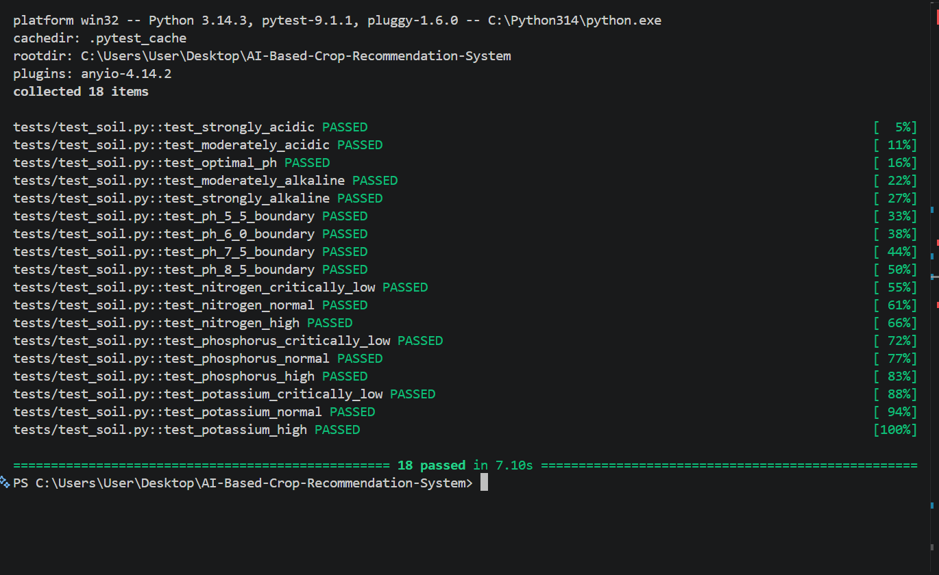

2. White-Box Testing
Test the internal code paths/branches.
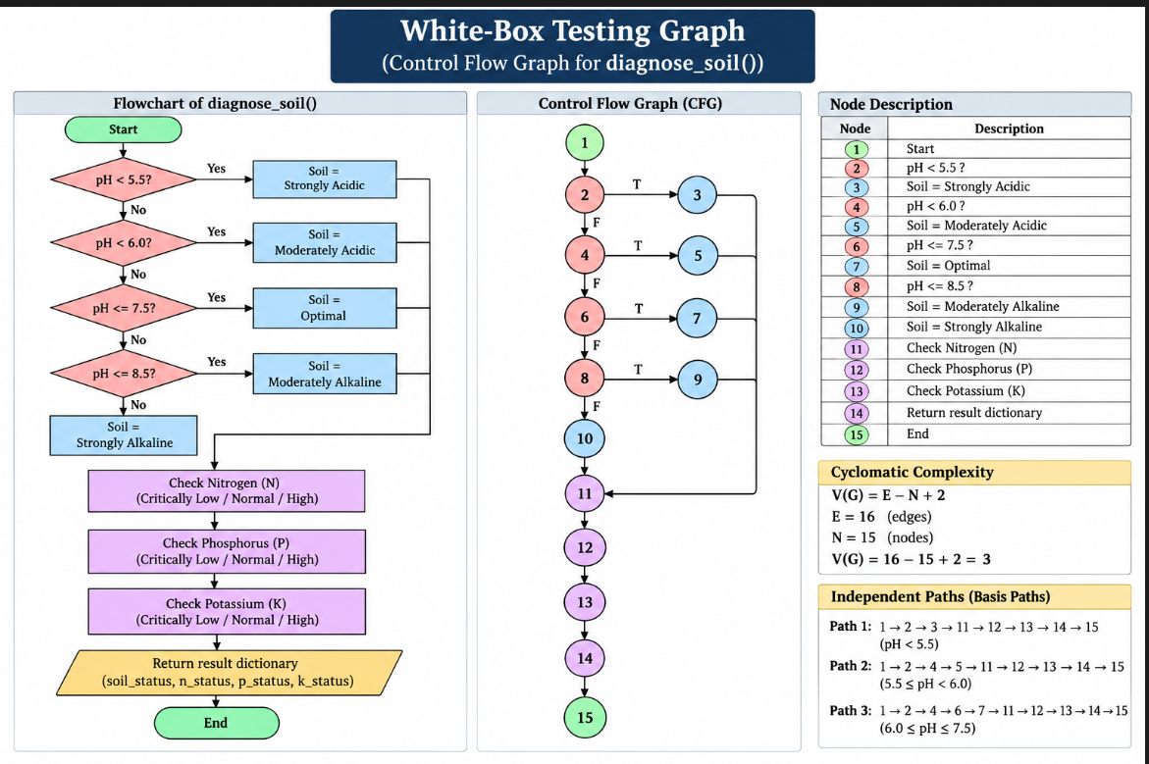
Test | Input | Path | Expected
WB01 | 5.0 | Branch 1 | Strongly Acidic
WB02 | 5.7 | Branch 2 | Moderately Acidic
WB03 | 7.0 | Branch 3 | Optimal
WB04 | 8.0 | Branch 4 | Moderately Alkaline
WB05 | 9.0 | Branch 5 | Strongly Alkaline
WB06 | 5.5 | Boundary | Moderately Acidic
WB07 | 6.0 | Boundary | Optimal
WB08 | 7.5 | Boundary | Optimal
WB09 | 8.5 | Boundary | Moderately Alkaline

3. Black-Box Testing
Test the application only through inputs and outputs.
ID | Parameter | Input | Expected
BB01 | All parameters | Valid values | Recommendation displayed
BB02 | N | -1 | Reject
BB03 | N | 200 | Accept
BB04 | N | 201 | Reject
BB05 | pH | 0 | Reject
BB06 | pH | 1 | Accept
BB07 | pH | 14 | Accept
BB08 | pH | 15 | Reject
BB09 | Rainfall | -1 | Reject
BB10 | Rainfall | 0 | Accept
BB11 | Rainfall | 500 | Accept
BB12 | Rainfall | 501 | Reject
BB13 | Required field | Blank | Validation/error

BB01
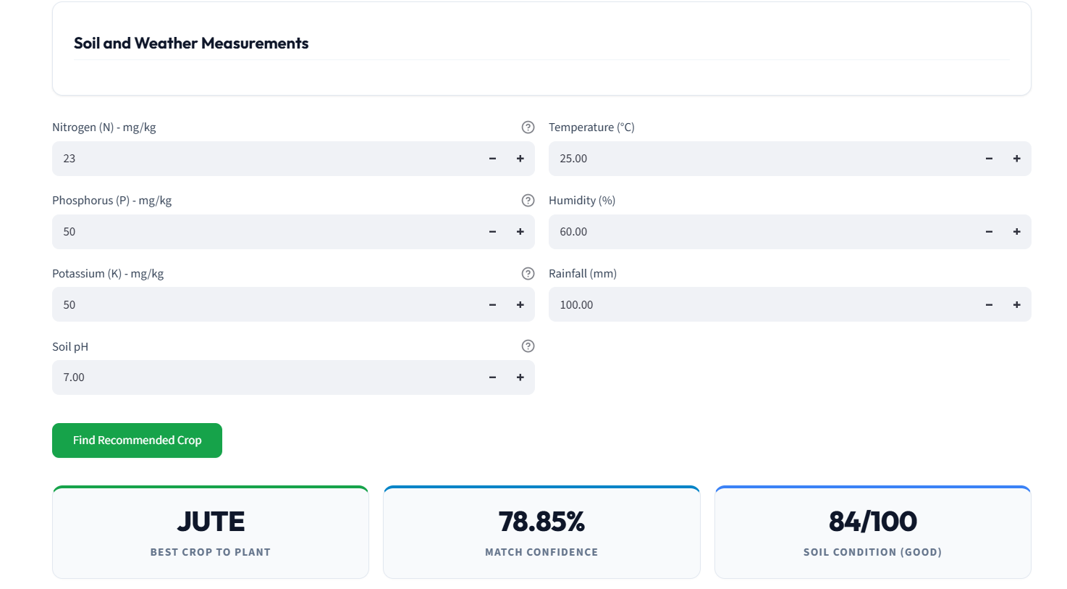
BB02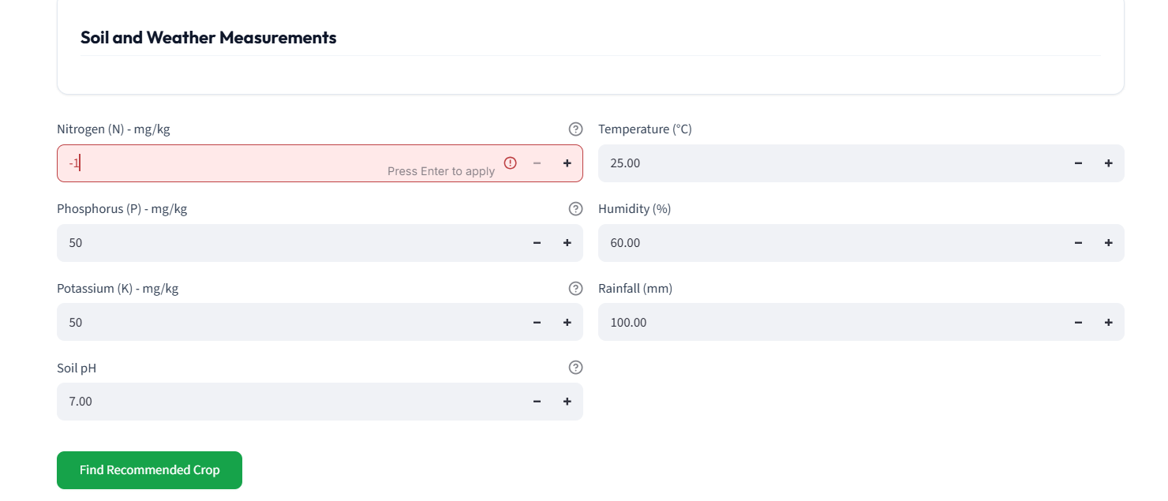
BB03
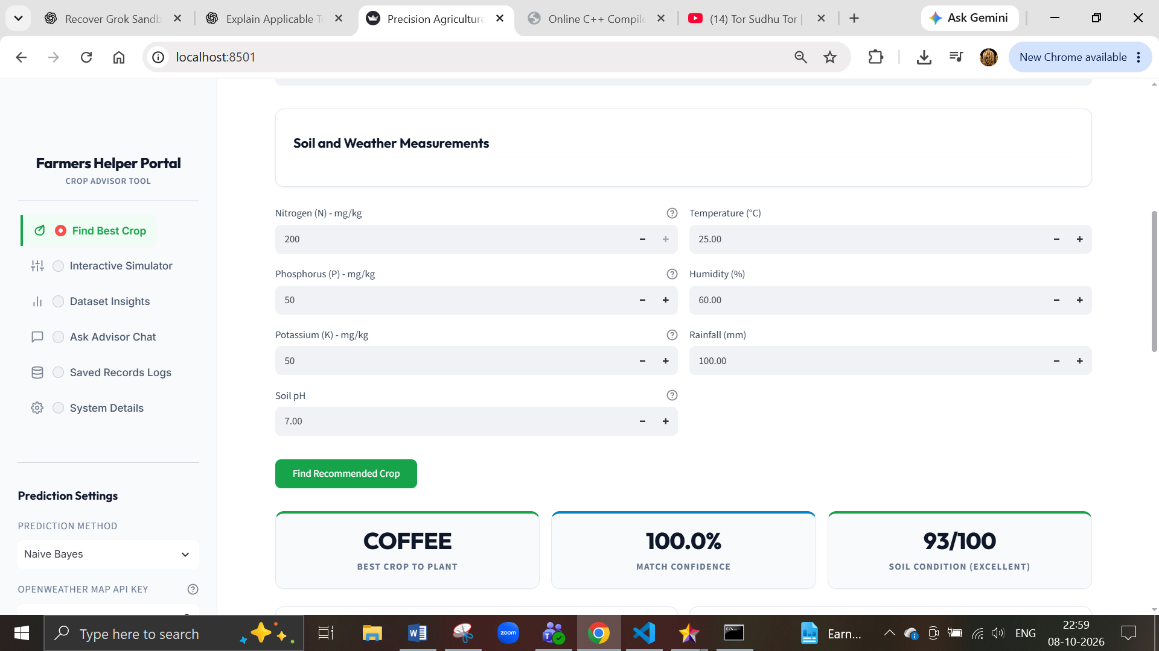

BB04
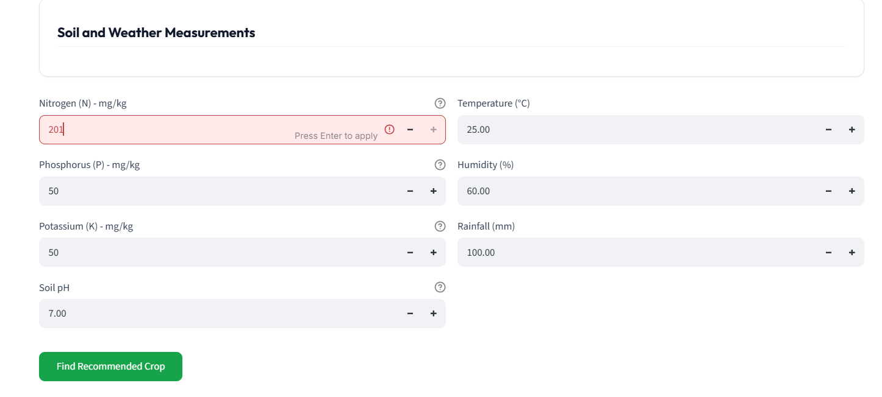

BB05
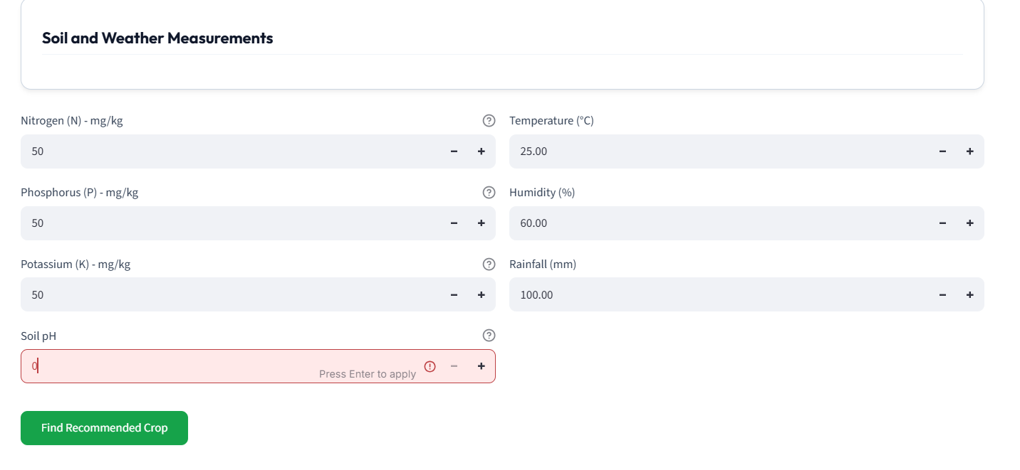
BB06
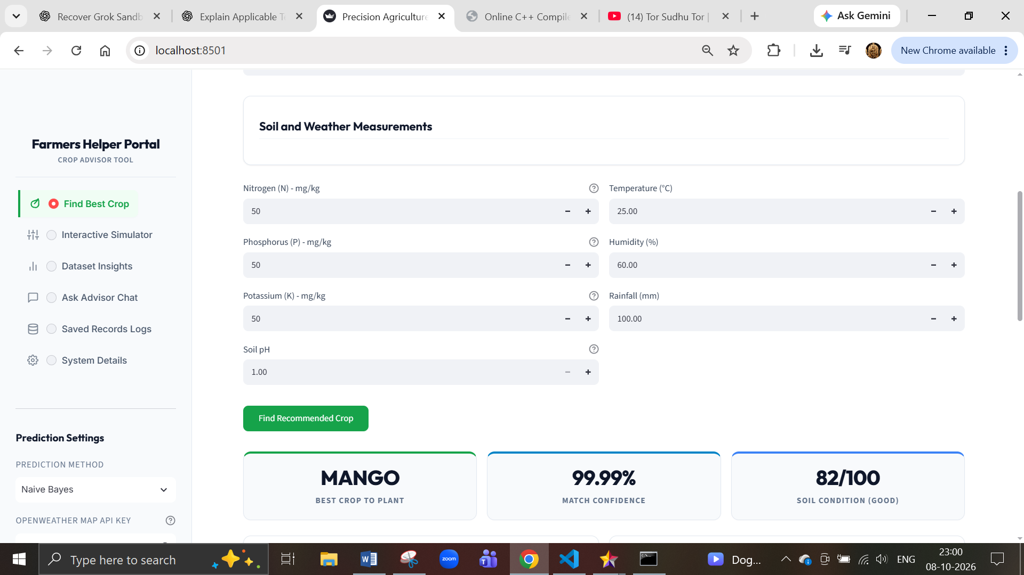
BB07
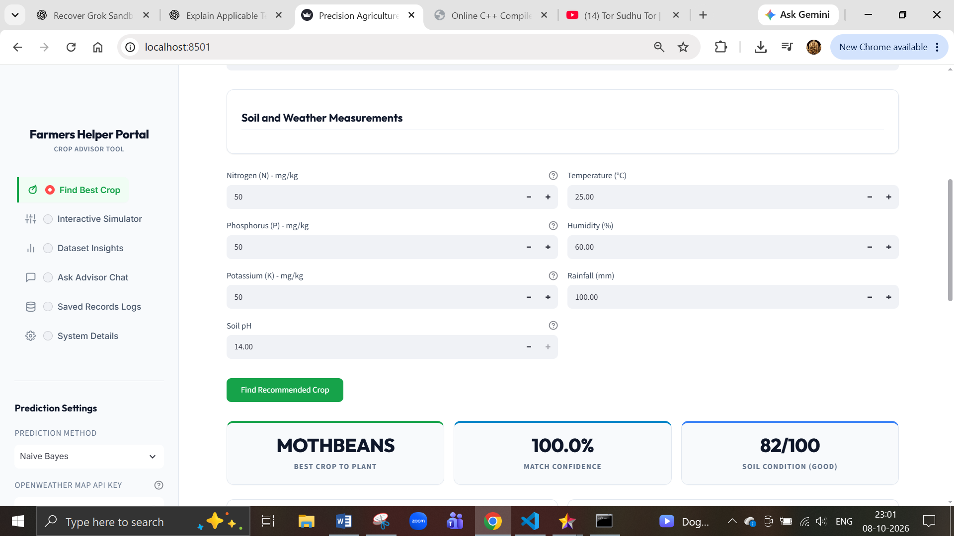
BB08
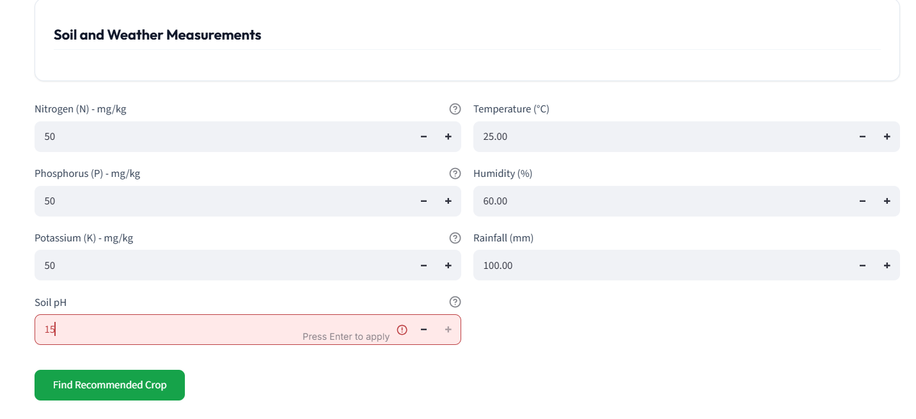

BB09
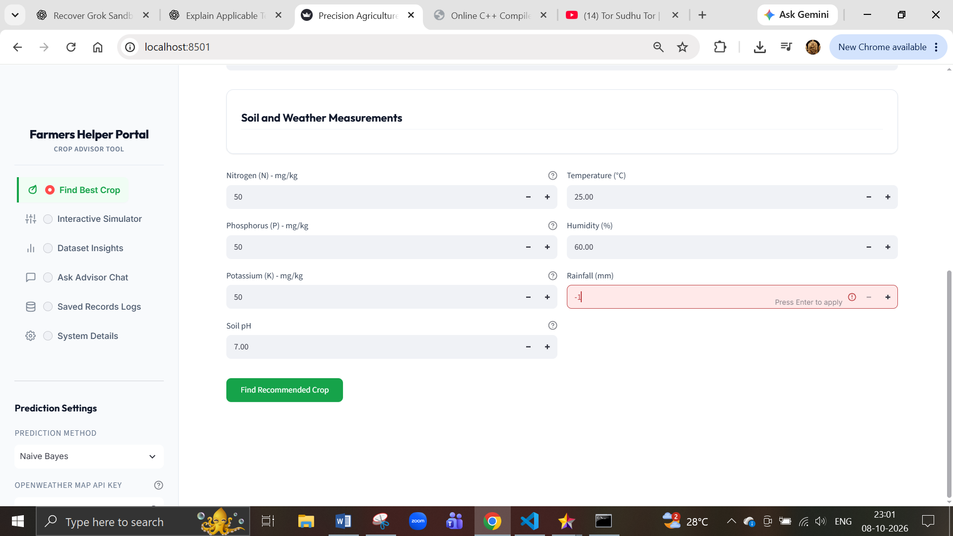

BB10
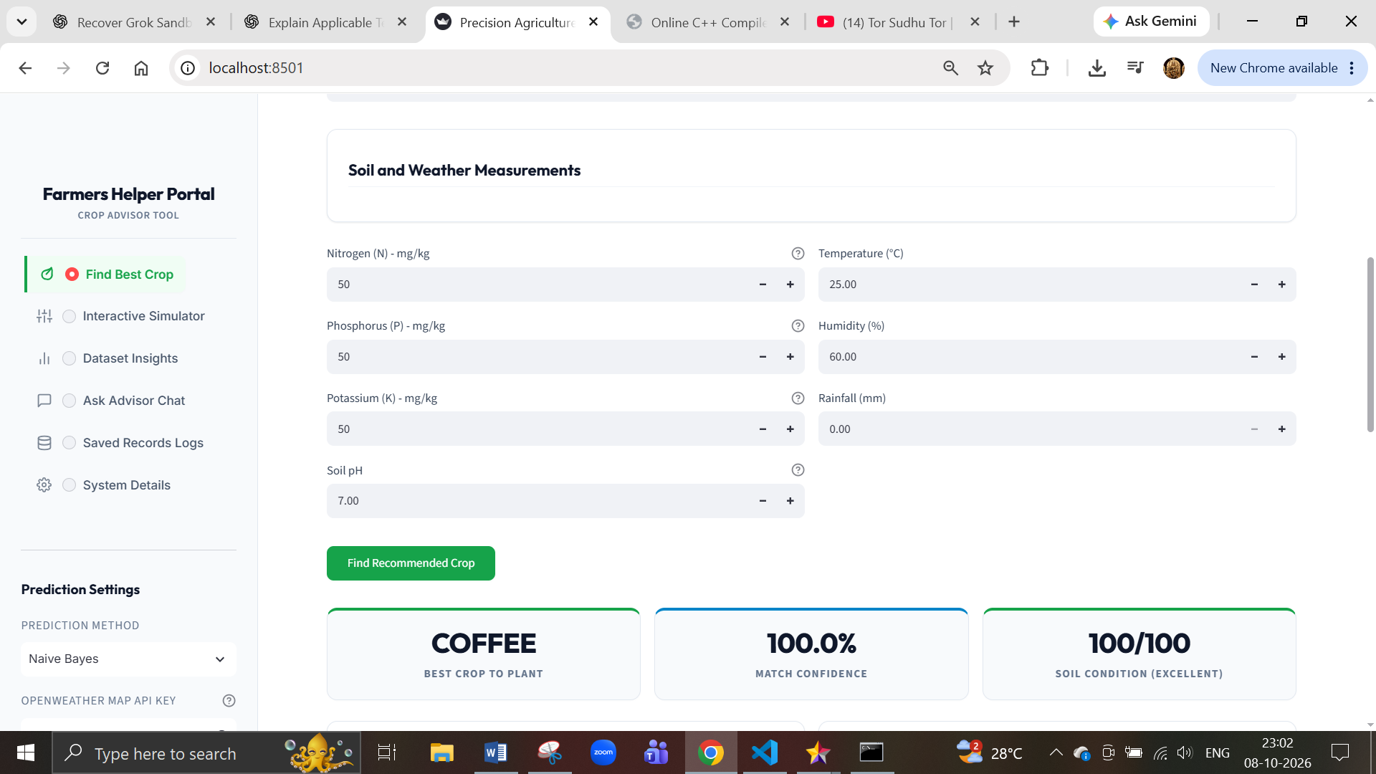

BB11
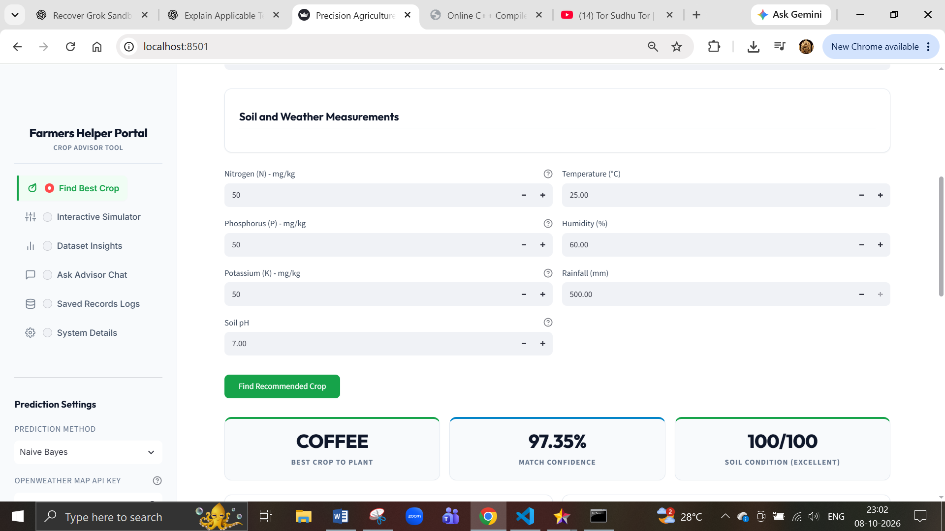

BB12
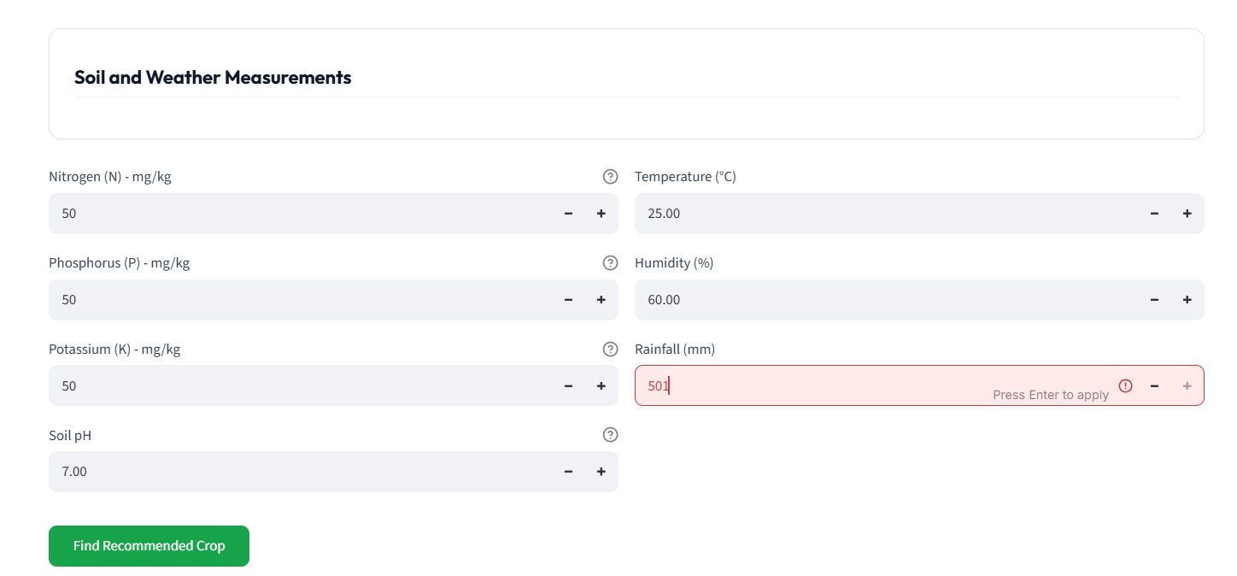

BB13
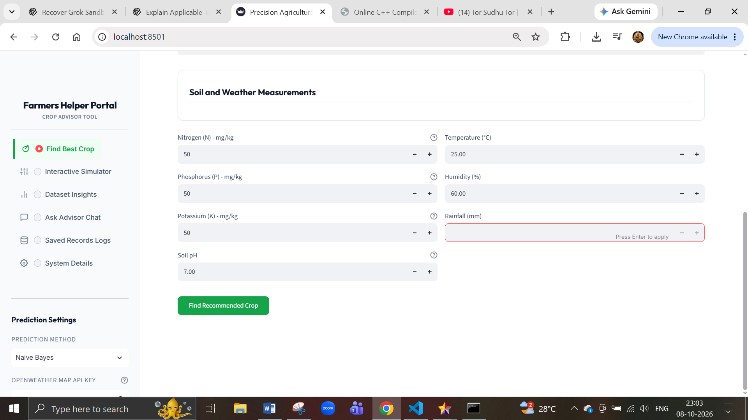

4. Integration Testing
Test whether the different modules work together.
ID | Integration | What it proves
IT01 | UI + ML Model | User input reaches model and prediction returns to UI
IT02 | Prediction + Database | Prediction is successfully stored
IT03 | Weather UI + API | External weather data reaches application

IT01
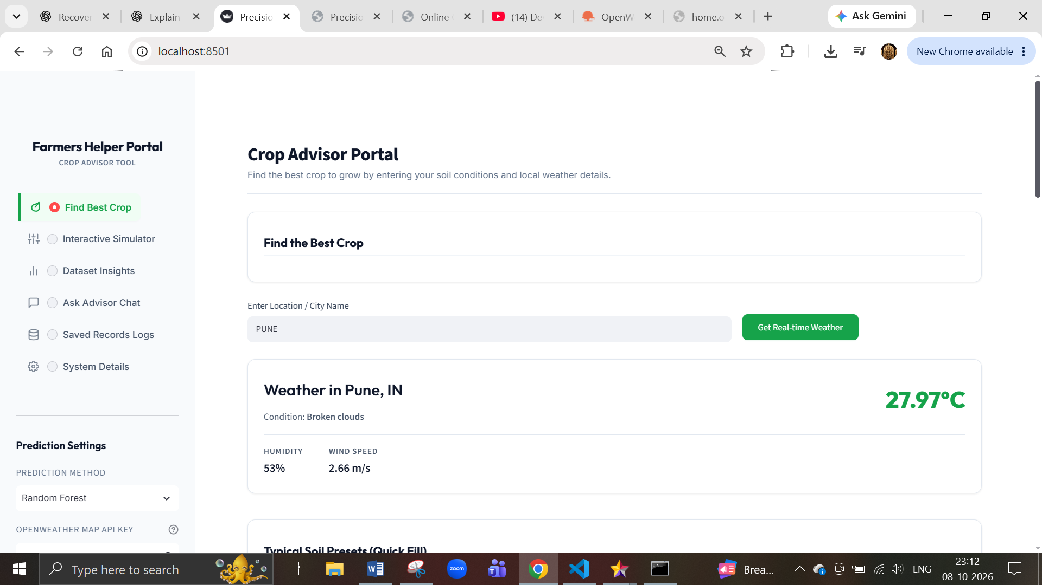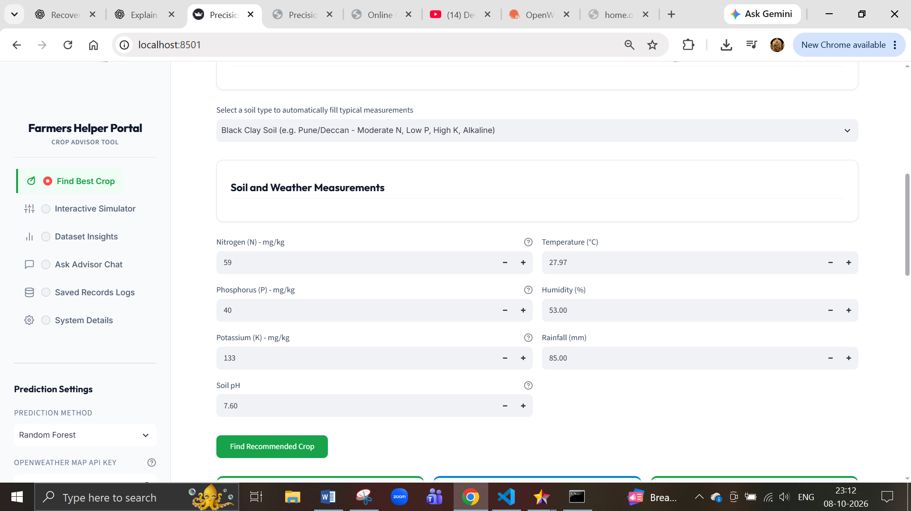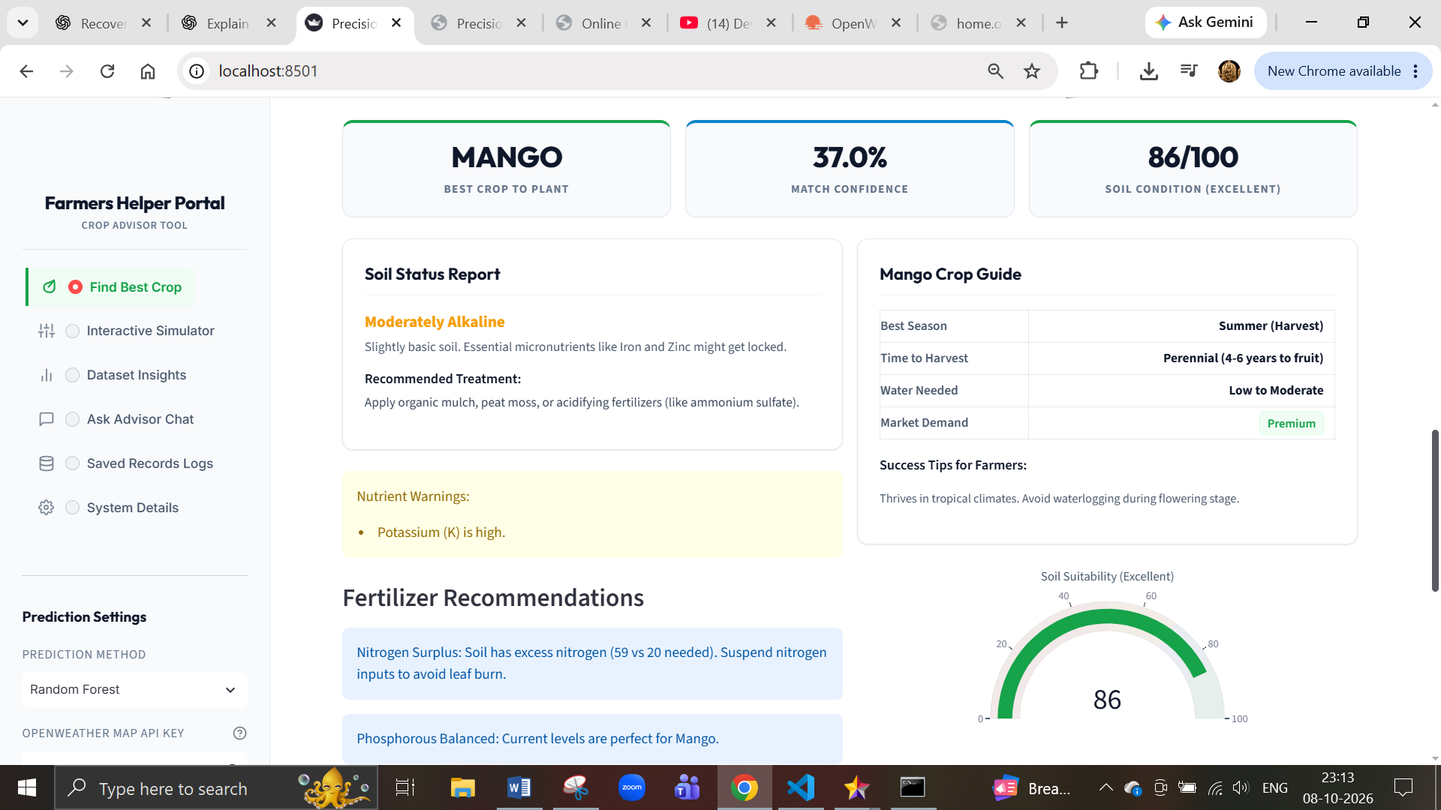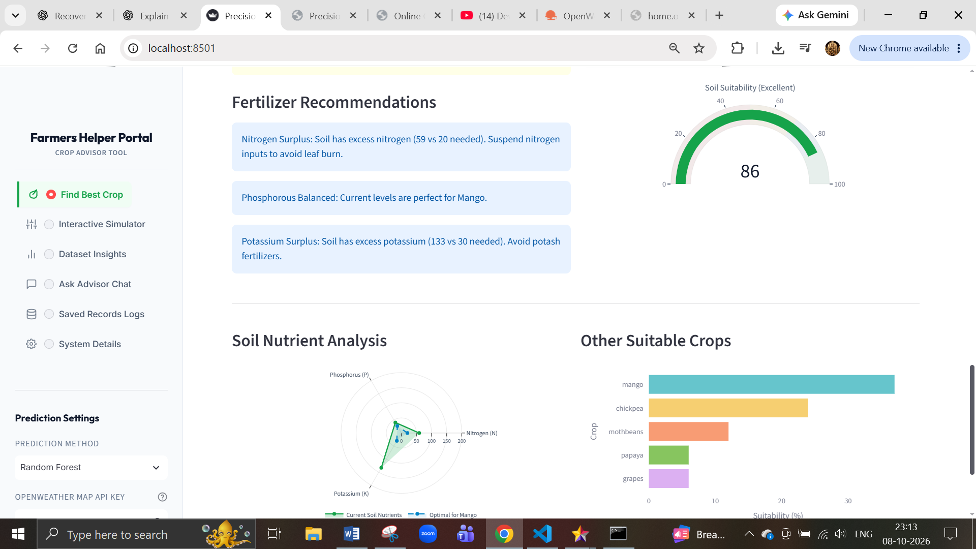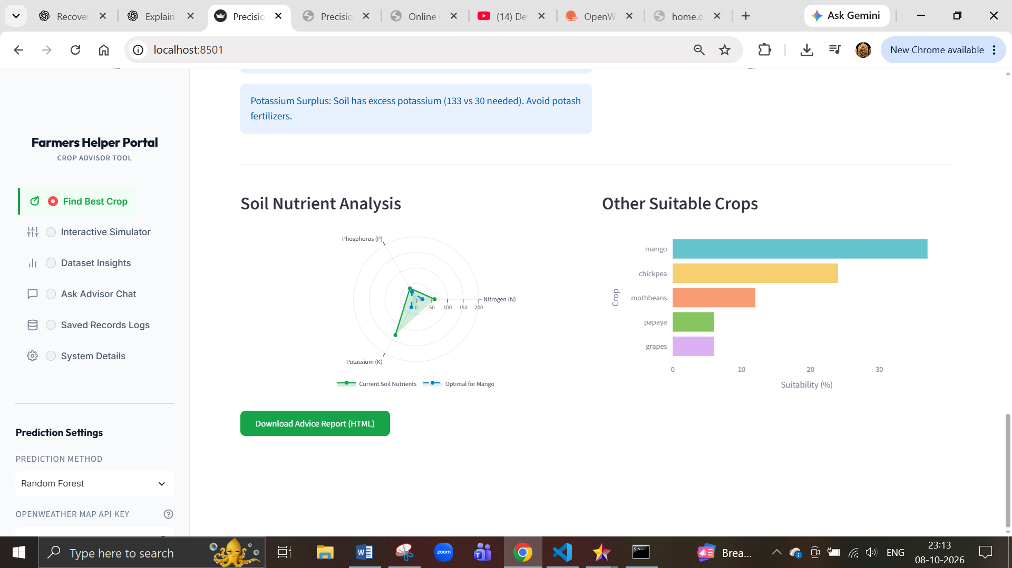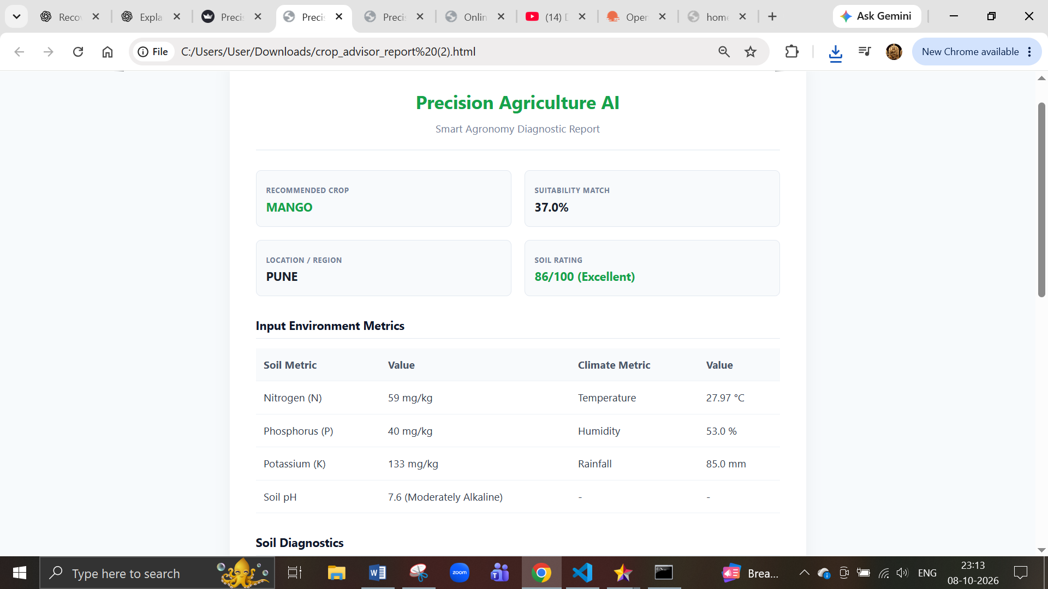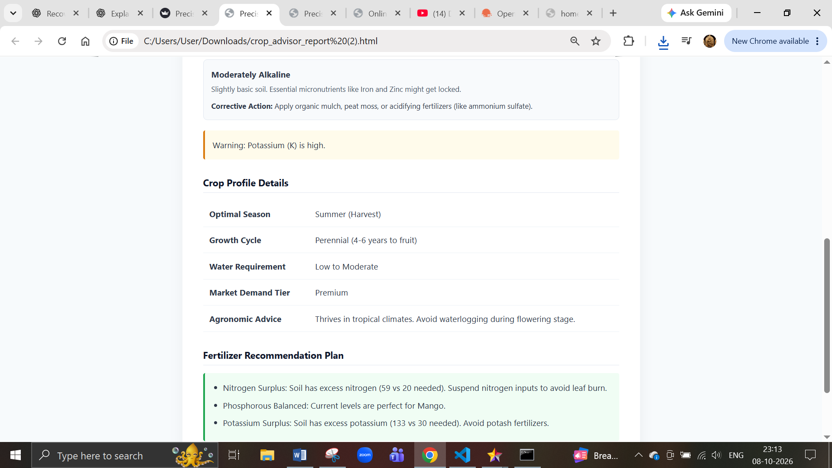
IT02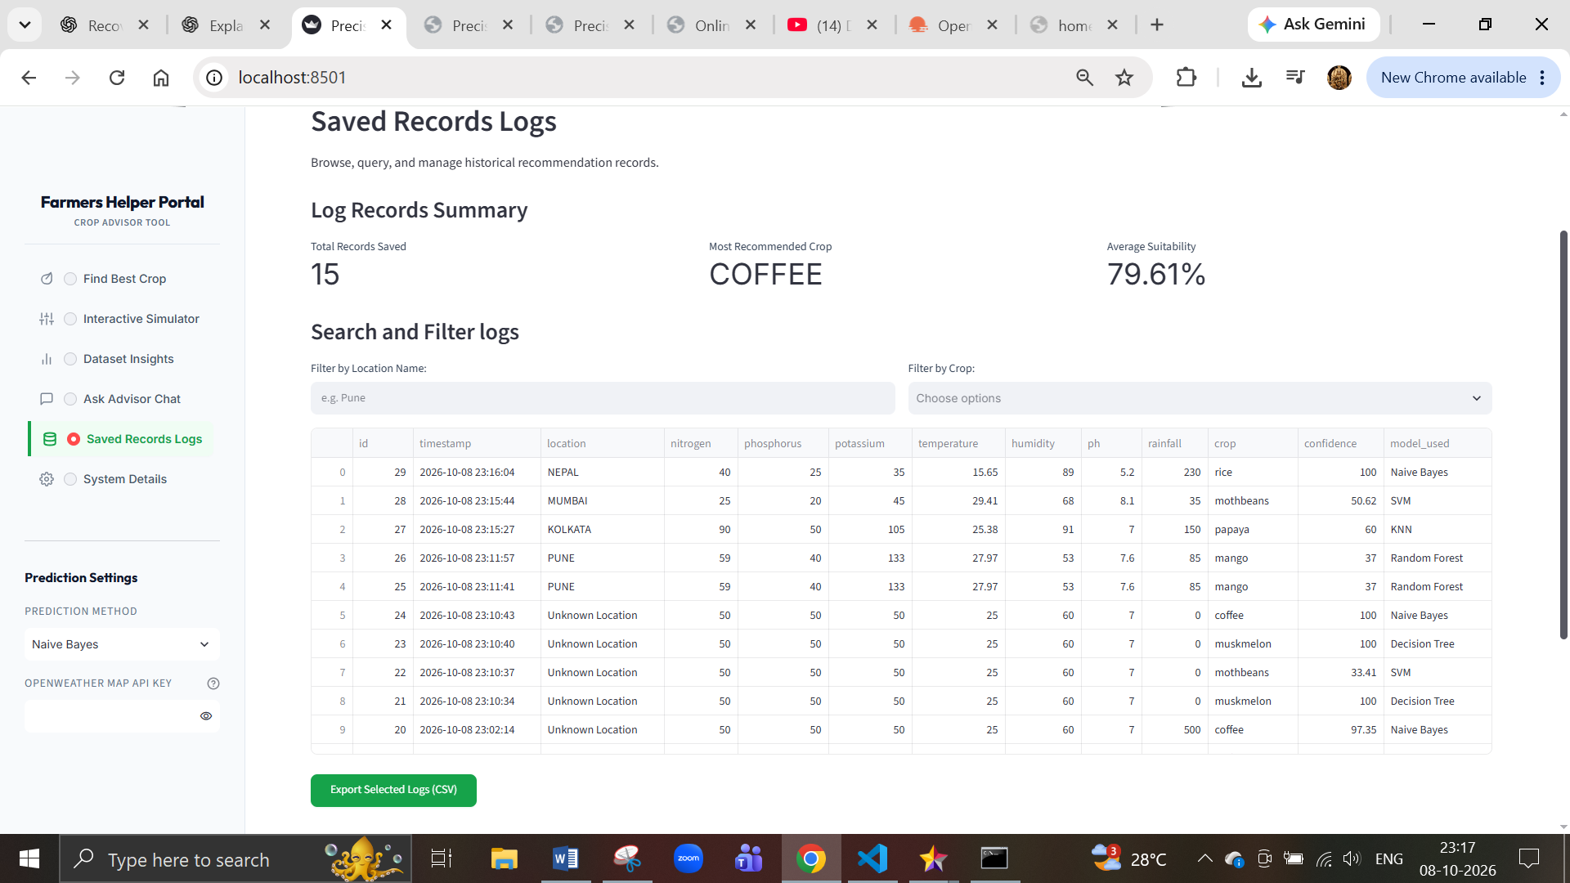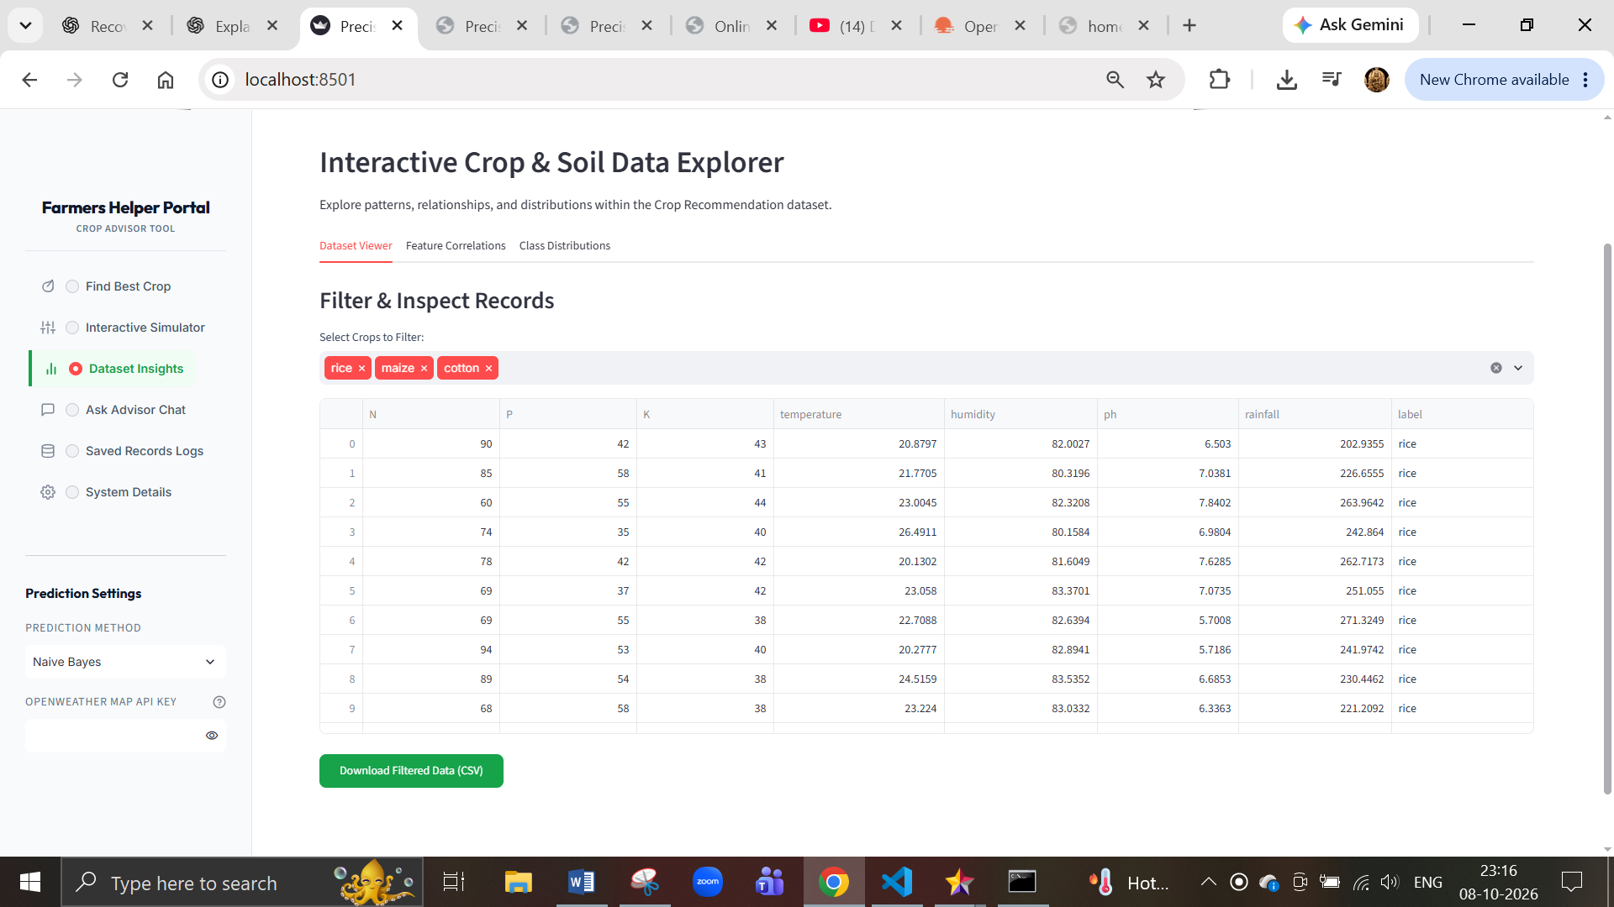 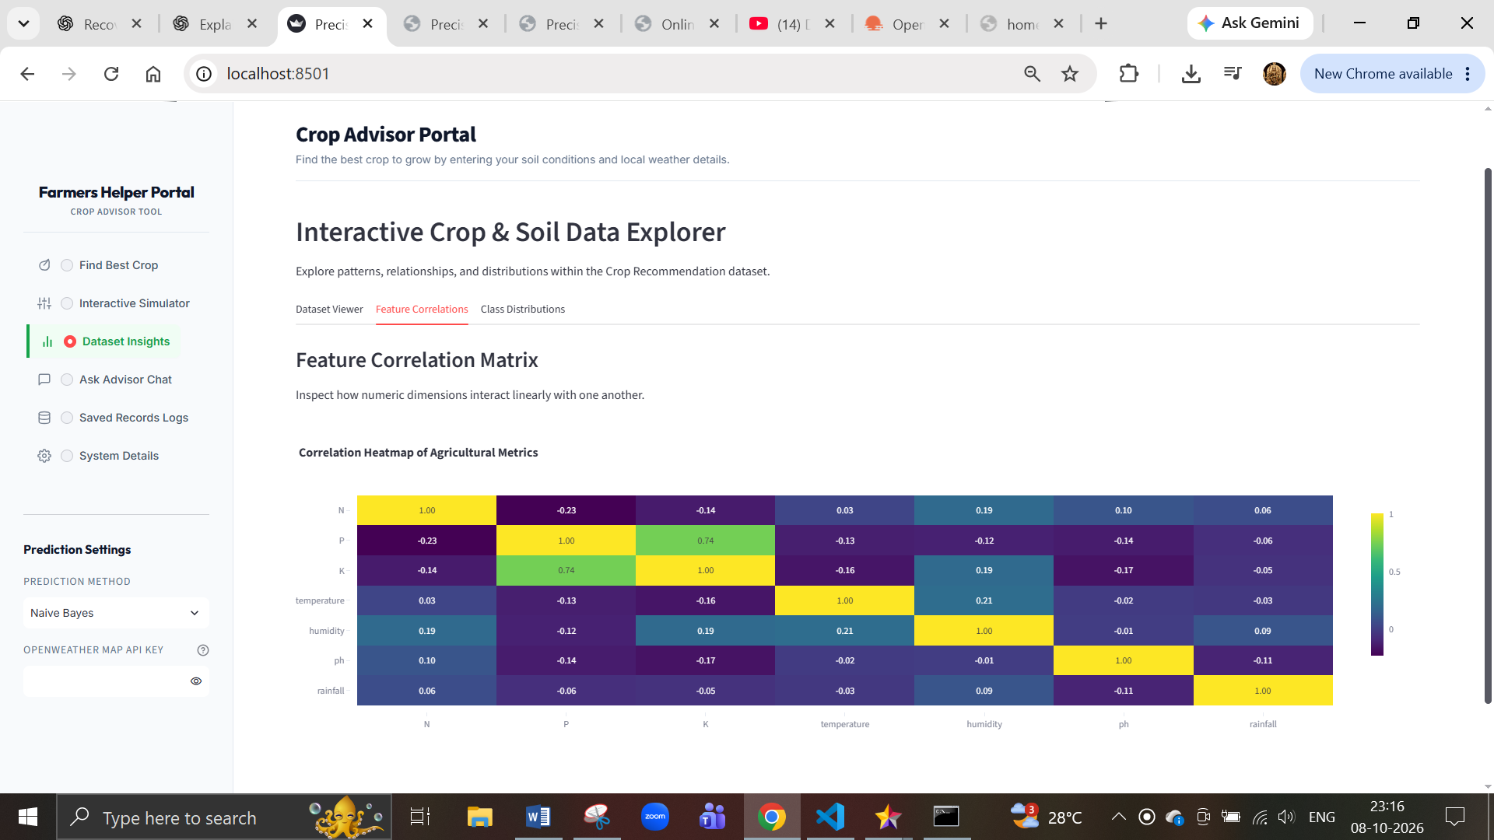 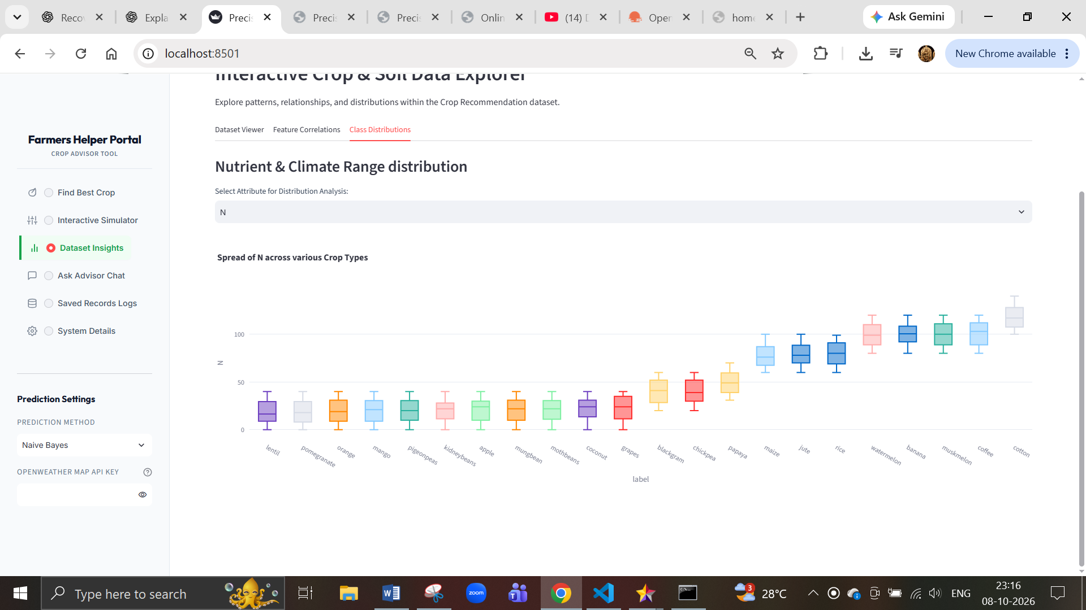 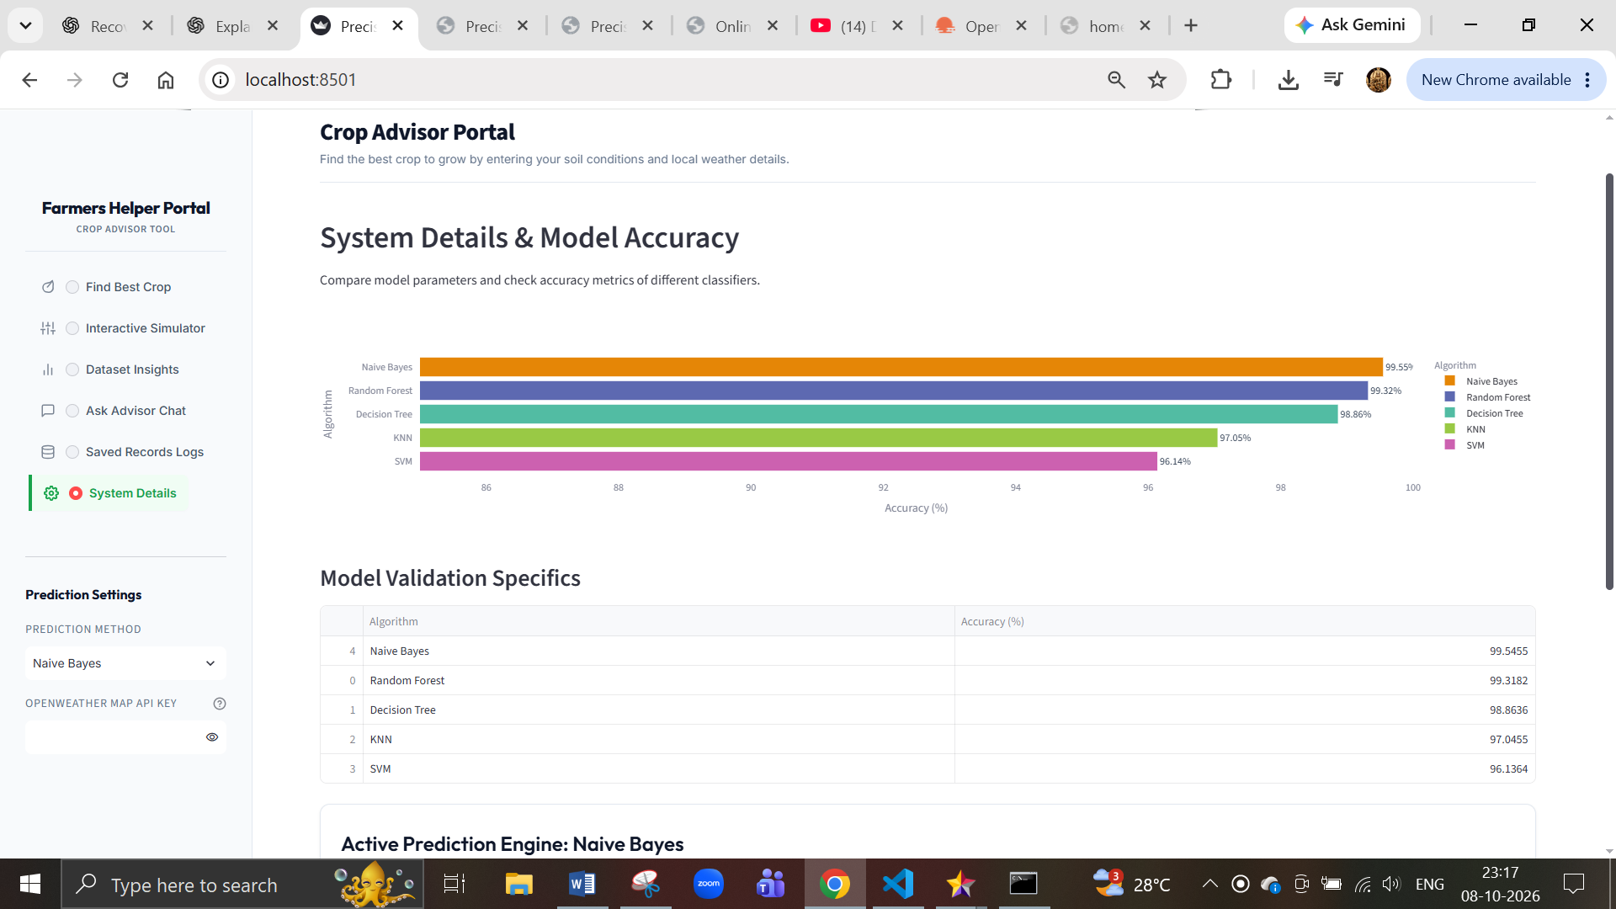
IT03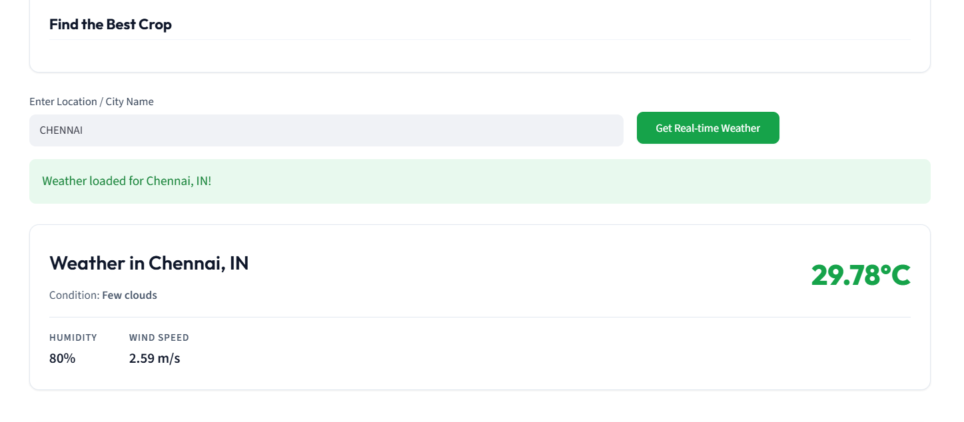 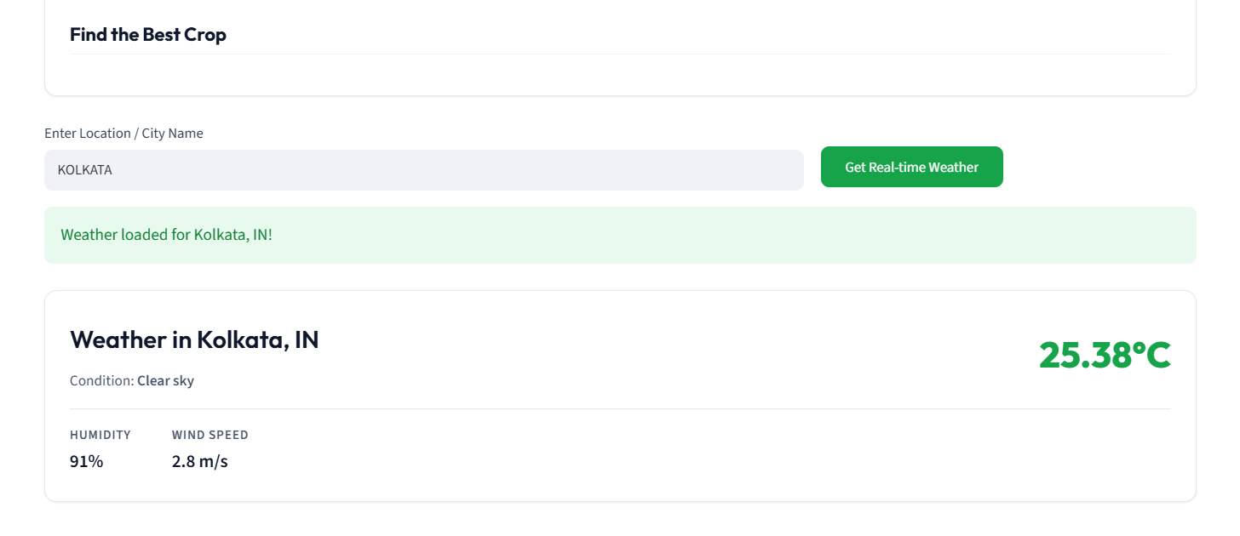 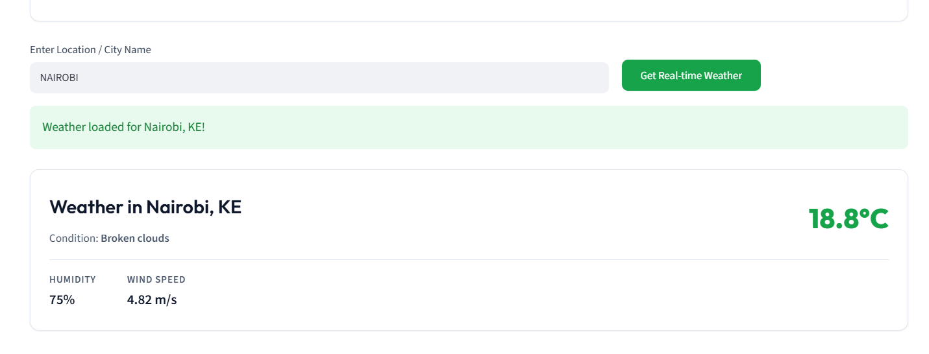

5. System / End-to-End Testing
Test the complete application as a user.

Test ID | System Function | Test Action | Expected Result
ST01 | Application launch | Open application | Application loads
ST02 | User input | Enter valid parameters | Inputs accepted
ST03 | Crop prediction | Click recommendation | Crop recommendation displayed
ST04 | Soil diagnosis | Submit pH/N/P/K | Soil diagnosis displayed
ST05 | Fertilizer | Complete recommendation | Fertilizer recommendation displayed
ST06 | Weather | Enter valid location | Weather information displayed
ST07 | History | Complete prediction | Prediction saved
ST08 | Complete workflow | Execute entire process | All components work together

